1. Download/save the certificate file “SunTrust Corp Internal Root CA 202.crt” to your **Downloads** folder or Desktop.
2. Locate the certificate file in Finder and **double click** it.

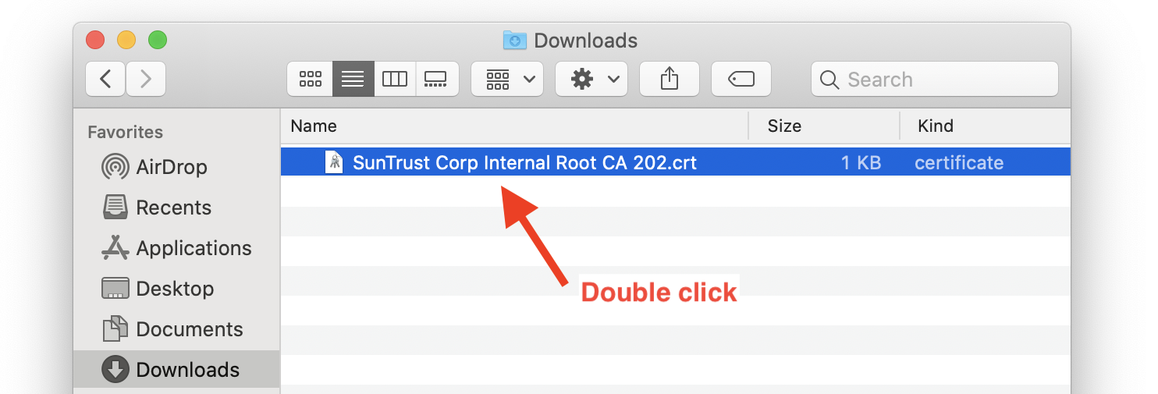

1. The **Add Certificates** window will appear. Make sure the “**login**” keychain is selected, then click **Add**.

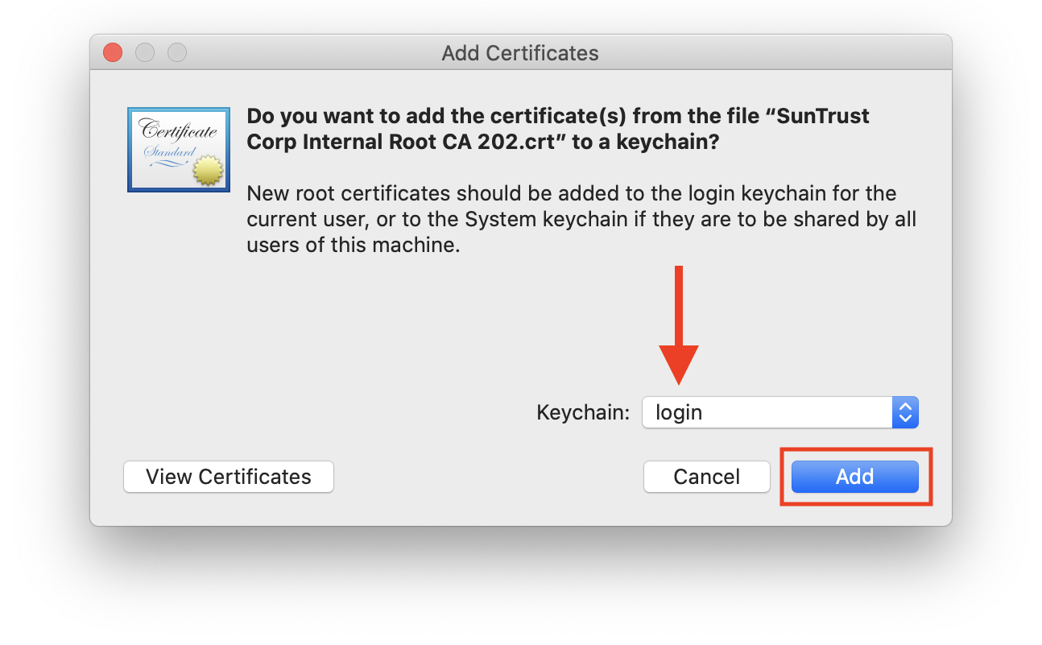

1. The Keychain Access utility will open. Select the “**login”** keychain in the upper left pane, and the certificate should be listed under the **All Items** category. You may also search for the certificate by name in the Search bar. Once located,  
   **double click** the certificate.

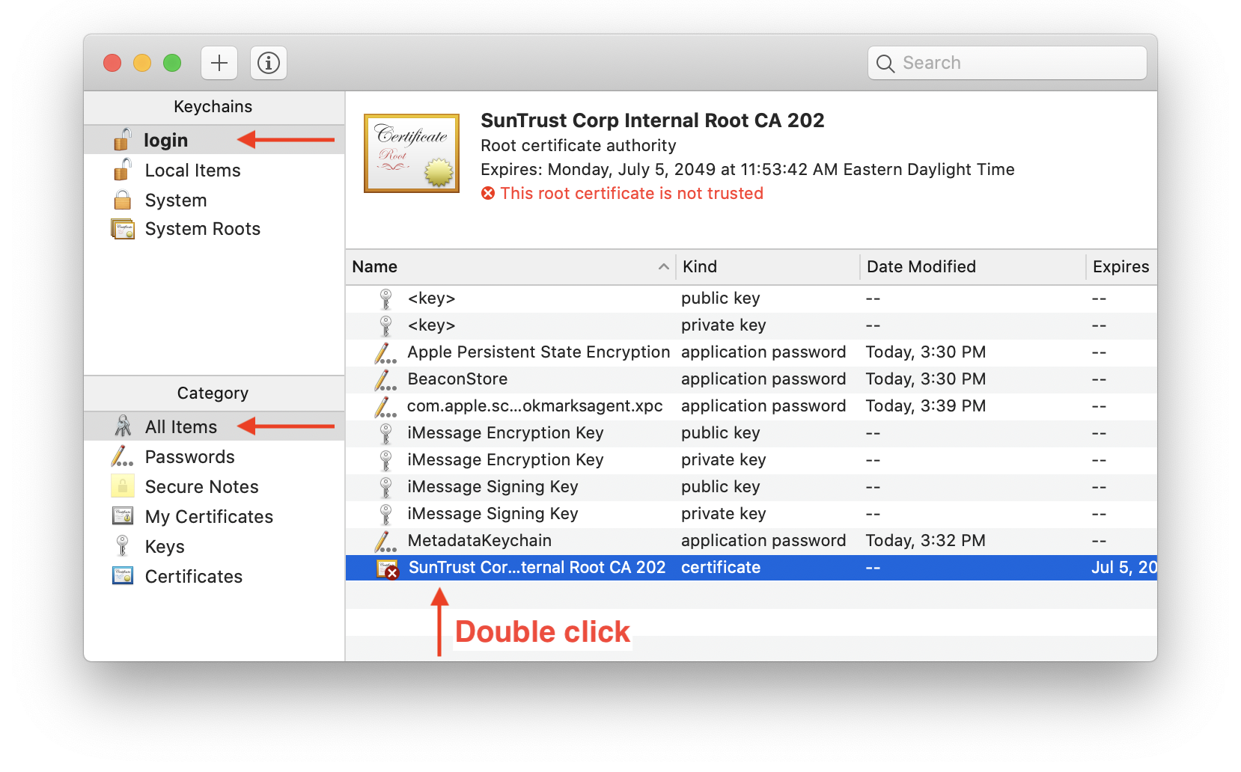

1. Click the small arrow next to **Trust**. Then click the drop-down list to the right of *When using this certificate:* and select **Always Trust**.

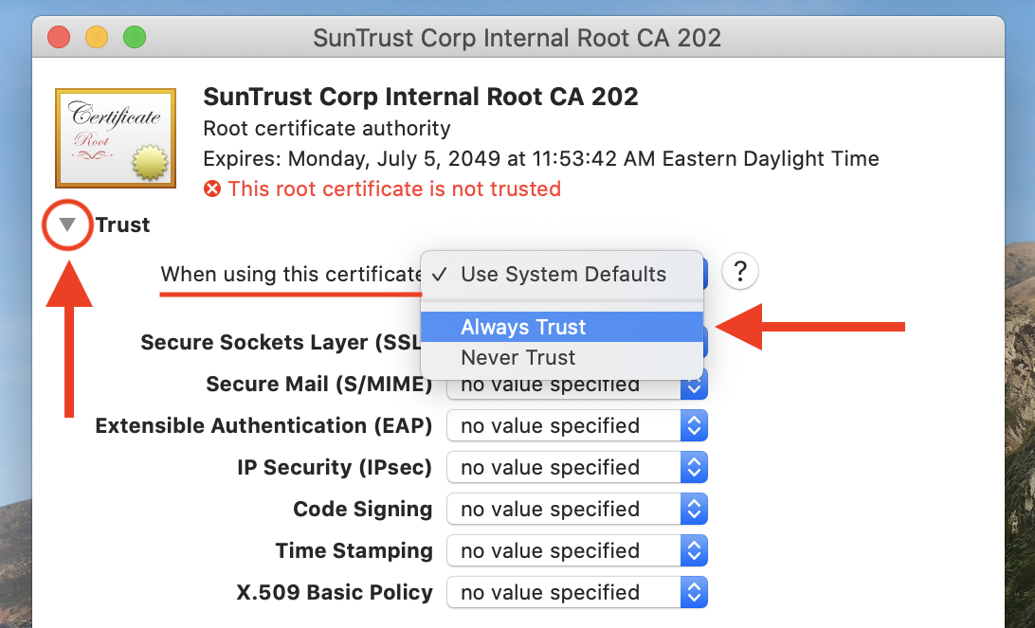

1. All of the drop-down lists will change to **Always Trust**. Close the certificate information window.

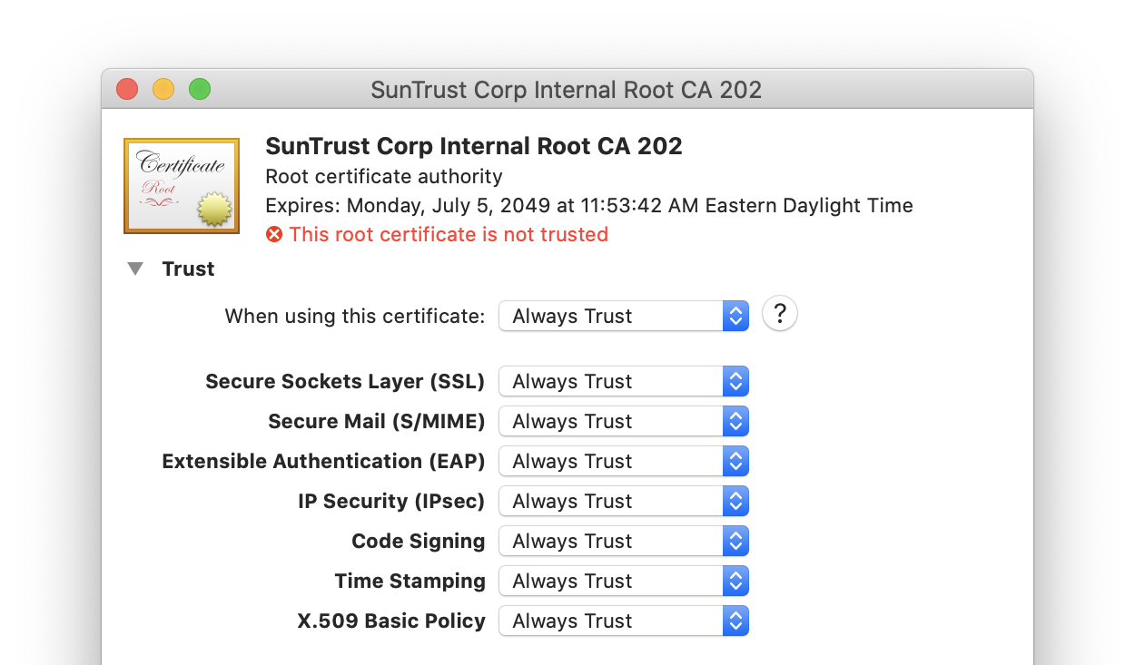

1. Agree to update the settings using Touch ID if prompted, or by entering your local Mac user name and password, then click **Update Settings**.

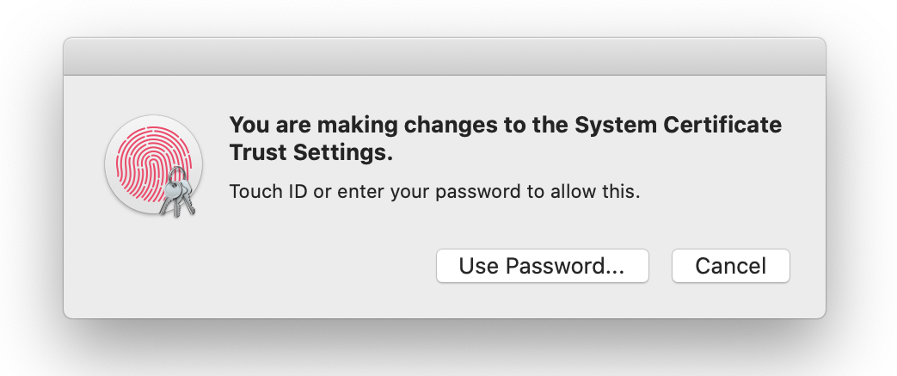

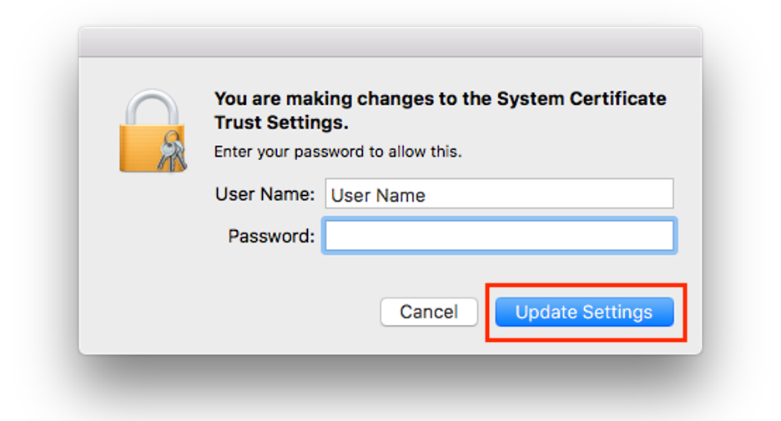

1. In Keychain Access, the certificate should now be marked as trusted. **Quit** (Cmd-Q) the Keychain Access utility and remove it from your Dock.

